**Using QuERI Data for Financial Analysis**

QuERI data can be used to help analysts understand the dynamics of markets and how these impact individual companies and sectors. Some of the possible uses in the financial sector include the following:

* Rebalancing multi-asset and multi-country portfolios using detailed industry and trade data across 72 countries.
* Projecting Company Revenues and

**Rebalancing multi-asset and multi-country portfolios**

QuERI data is multi-country and multi-industry. It’s available as broad industry aggregates down to commodity detail by NAICS 6 groups. Covering 72 countries and six major regions plus world, it’s ideal for developing ETF indices or share portfolio’s that are globally balanced by industry, regions, or globally. As the tables show shares will change over time. Thus QuERI baselines can be used for a forward looking at which industries and sectors will be increasing their share of the global economy and which will be losing share.

QuERI data is fully consistent in definitions across industries and in value measures (current and real US 1995 dollar prices and exchange rates). Updated using the latest available international trade, industry and macroeconomic data with new baseline estimates for forecasts developed quarterly, QuERI industry and trade data is the most complete source for developing unique, industry and country specific, portfolios of international shares and indices.

To illustrate one possible approach to a globally balanced portfolio we have prepared tables based on 19 broad industry and service categories for the 6 major regions, the seventh region is the world. If a portfolio of ETF’s or stocks were to reflect the global economy then the share of each of these relative to the world output should be approximately the proportions shown. Global output or production data adjusted for differences in prices and exchange rates (consistent to 1995 US $ values) are used as a base. As we can see these will change over time. The shares for 2011 are different from 2013. Thus any adjustment might take into account the forward looking year.

**Table 1: Global Shares of Output by Broad Categories & Major Regions 2011 & 2013**



Alternative weights may be based on the regional shares of the products. Table 2 illustrates this kind of approach. Given the detail available from the underlying QuERI databases these type of splits can be developed for countries and more disaggregated products. Looking at High Technology products we can see that in 2011 Asia’s share of global output was 67.3% but falls to 62.4%. The difference is made up by the increasing share of high technology produced in the United States from 13.7% to 17.4%.

**Table 2: Global Shares by Regions for Broad Categories – 2011 and 2013**



**Forecasting Company Revenues (Next Year, 5 Years, and Long-term)**

QuERI data improves performance of analysts’ estimates of next year’s revenues by adding additional factors for measuring performance and future revenues. We have developed a very simple multi-company model for revenues by company for the top 25 integrated steel producers globally using QuERI data for iron and steel products as independent variables to estimate company revenues (dependent variable).

A very short time series covering 2008 through 2012 is used illustrating the ability of a multi-company-time-series econometric model to work with short time period. Another advantage of using shorter time series and developing a joint cross sectional model rather than time series models is that it allows current conditions in the industry to be measured rather than past patterns that may no longer be appropriate. Another advantage is that we can measure relative success of companies using a standard model rather than fitting models to individual company data that will not allow statistically interesting comparisons of performance. An index of performance is calculated by comparing the Actual/Estimated. If a company is underperforming then the index will be less than 1.0 and if over performing the industry performance it will be above one.

A simple, multi-company and multi-year model is developed using econometric software. Each company is assigned a sponsoring country and given the concentration of production generally in a single country rather than distributed globally (there are exceptions of course and these will be accounted for by the global variable in the model) we can use the geographic data as a good proxy for where the major assets are deployed. In the case of other industries the companies own split of revenues by region or country can be used and the QuERI data used as an weighted aggregate by company.

A log-linear model where the coefficients reflect point elasticity’s is estimated using E-views software that allows pooled-time series models to be efficiently estimated. Unlike Four country specific variables are used:

* Steel production for domestic consumption and exports;
* Steel Exports
* Steel Imports
* Steel Market Demand
* Global Internationally Traded Steel Market Demand (imports).

Nominal US dollar values are used that take into account changes in exchange rates and prices. A generalized model is used with coefficients estimated for the four country specific variables rather than different coefficients for each country and each variable.

To account for other factors we have included a separate variable with coefficients estimated specific to each company using the world market size for traded steel products as the independent variable. This allows the model to account for companies that have a higher share of their production going to exports or where they have significant revenues coming from facilities outside of their primary domiciles.

**Table 3: Companies with Positive Elasticity’s for International Trade**



These four countries are major exporters of iron and steel to the world. In 2012 these four countries accounted for 24% of world trade in iron and steel.

**Table 4: Country Shares of Global Steel Trade**



**Figure 1: Multi-Company Times Series Model**

An analyst may not have access to data on industry performance drawn from an independent sample of government data. Even if this data is available for the historical period it may not be tied to an integrated model that takes into account, as the QuERI model does, demand for the product coming from the growth or decline of other industries. As a substitute they may use Arima or time-trend models or more general variables such as GDP or trade that may be available. Two possible variants are developed to test how well a model using detailed QuERI industry and commodity terms does against more general models. The QuERI model will be called QuERI and the other two, one with just a time trend for each company’s past performance used to project it’s future revenues (Time Trend) and the second variant where GDP is included as a common variable (GDP-Trend) are developed.

We can see from this table that the variance, measured by the standard deviation of the yearly errors over the average of the 5 years is lower for most countries for the QuERI model. Adding GDP appears to do little to improve the fit nor reduce the variance. When the variance is lower for the other two models, however, the actual error may be significantly more. For example in the case of Tata Steel revenues the average error is less than 5% for the QuERI model but the over estimate of revenues is 23% for the time trend only and 15% for the trend model including GDP.

**Table 5: Comparison of Model Developed Deviation Factor (2008 – 2012)**



Another measure of accuracy or performance is how well the model can adapt to changing trends in the industry. A model based solely on company performance in the past and independent of the industries performance will tend to either overshoot or undershoot future performance. We can test this using the comparison of the actual growth rate for the history for the company (2008-2012) with the growth based purely on the model estimates. The table shows the results. While in some cases the error (difference in growth projections estimates – actual) is smaller for the GDP-Trend model than the QuERI Model, in general the QuERI model picks up the true trend and likely future growth. A collapse in steel demand will lead to a decline in production and revenues or a boom in steel will do the opposite. While the estimates from QuERI of steel production, demand, exports and imports are themselves based on models they are dependent upon growth in sectors that purchase steel (autos, ships, aircraft, machinery, etc.).

**Table 6: Comparison for Actual Revenues to Model Projected Revenues (2008-2012)**



Using the QuERI model we can project forward and back estimates of company performance (nominal dollars, millions). Over this period 1990 through 2025 the share of the Top 25 Steel producers has declined relative to the growth of the world. Smaller steel producers and fabricators, using abundant supplies of scrap steel, can now produce finished ingots and rolled products in smaller countries and with smaller companies.

Figure 1: Top 25 Steel Companies compared to World Production Iron &Steel (1990 – 2025)

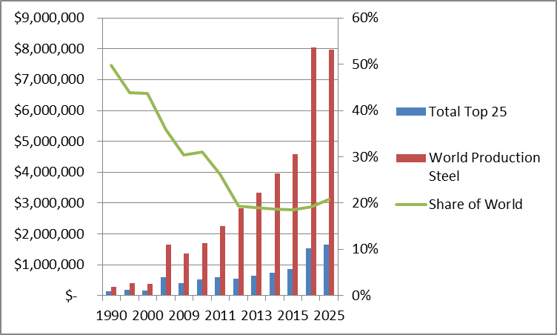

QuERI Model Baseline Forecast for Top 25 Steel Producers – 1990 – 2025

